**LAB EXAMINATION – 2 (COMPUTER NETWORKS)**

**(RA2211026050100)**

Objective:

Set up and configure a network topology using RIP and OSPF routing protocols in Cisco Packet Tracer. Customize the network by assigning each computer a name and an IP address using the last three digits of the roll number.

Procedure:

1. NetworkTopologyDesign:

o Createatopologythatincludes:

10-12 computers distributed across two LANs.

Use two switches, each connecting a group of computers in a separate LAN.

Two routers connected via a WAN link. o Device Distribution:

LAN 1: 5-6 computers connected to Switch 1.

LAN 2: 5-6 computers connected to Switch 2. o Device Naming Convention:

Each computer was assigned a name in the format: PC_RollNumber (e.g., PC_123).

1. IP Address Configuration:

o AssignIPaddressestothecomputersineachLAN.

LAN 1: IP addresses configured with the subnet 192.168.1.0/24, where each PC's IP address ends with the last three digits of the roll number (e.g., 192.168.1.123 for PC_123).

LAN 2: IP addresses configured with the subnet 192.168.2.0/24, similarly using the roll number for the last octet (e.g., 192.168.2.123 for PC_123). o Router Interface Configuration:

Router 1 interfaces were set up with the IP address 192.168.1.1/24 for LAN 1.

Router 2 interfaces were configured with 192.168.2.1/24 for LAN 2. The WAN link between routers used a point-to-point subnet (e.g., 10.0.0.1/30 for Router 1 and 10.0.0.2/30 for Router 2).

1. Routing Protocols Configuration:

o ConfigureRIPv1onRouter1:

Added the network commands for 192.168.1.0 and 10.0.0.0 to enable RIP routing. o Configure OSPF on Router 2:

OSPF was set up using the area 0 configuration.

Added network commands for 192.168.2.0 and 10.0.0.0. o Ensuring Communication:

Verified that the routes were properly advertised and shared between the two routing protocols using route redistribution.

1. Packet Tracer Configuration Steps:
   * Add Devices and Create Connections:

Placed all computers, switches, and routers in the workspace. Connected devices with appropriate cabling (copper straight-through for computers to switches and serial connections for routers). o Configure IP Addresses:

Manually set IP addresses for all computers and configured default

gateways.

* + Set Up Routing:

Enabled RIP on Router 1 and OSPF on Router 2.

Configured route redistribution on both routers for seamless communication. o Verification:

Used the ping command to test connectivity between LAN 1 and

LAN 2.

Verified route tables on both routers to ensure correct route advertisement.

1. Simulation:
   * CiscoPacketTracerSimulationMode:

Switchedtosimulationmodetoobservepackettransmission. InitiatedmessagesendingfromacomputerinLAN1toacomputerin LAN 2.

Verifiedthesuccessfultransmissionofthemessageandinspected routing paths.

1. Documentation and Submission:
   * ProcedureDocumentation: Step-by-step process of network configuration was documented as described above. o Screenshots: Added all relevant screenshots, covering network design, IP configurations, and successful message transmission.
   * PacketTracerFile: Saved the .pkt file with the completed configuration.
   * GitHubSubmission: Uploaded all documents, screenshots, and the .pkt file to a GitHub repository named "Lab 2 Exam". o RepositorySubmission: Submitted the GitHub repository link to the instructor.

Output Screenshots:

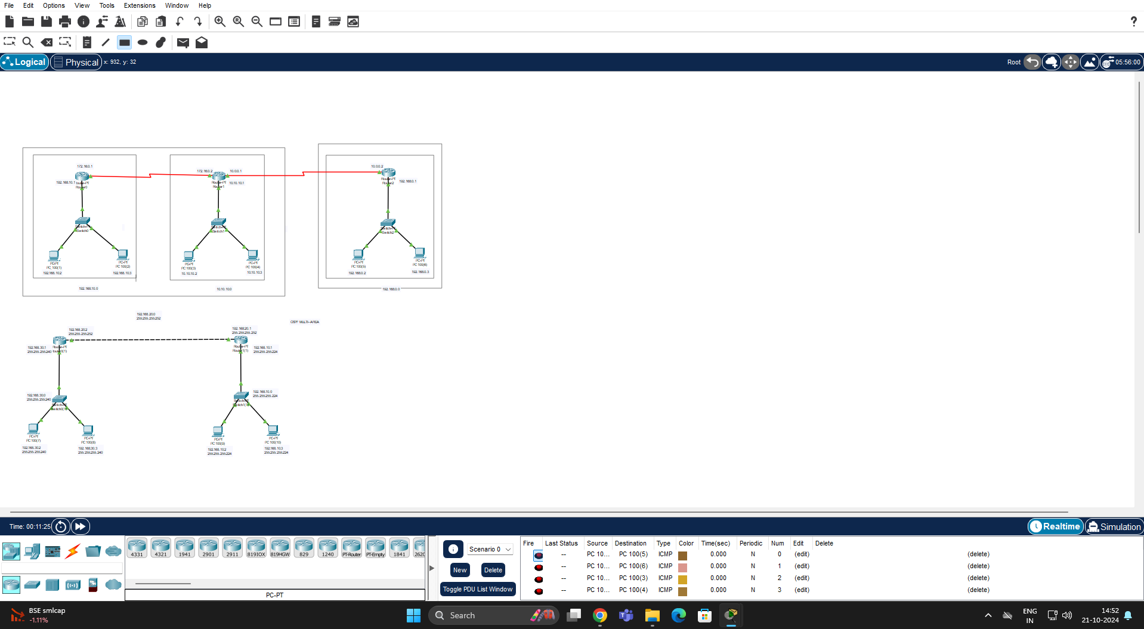

Results:

* Successfully configured a network topology with two LANs using RIP and OSPF routing protocols.
* All devices were assigned IP addresses based on the last three digits of the roll number, maintaining the required subnet structure.
* Routing protocols were configured on the routers, allowing seamless communication between LAN 1 and LAN 2.
* The simulation mode in Cisco Packet Tracer demonstrated successful packet transmission across the network.
* Documentation and files were submitted as per the requirements.

Name: suvetha.B

Class: CSE AIML -B